*TASK 1:-*

WAP to input a string and print reverse a string or exchange position of starting index char to the last index respective position.

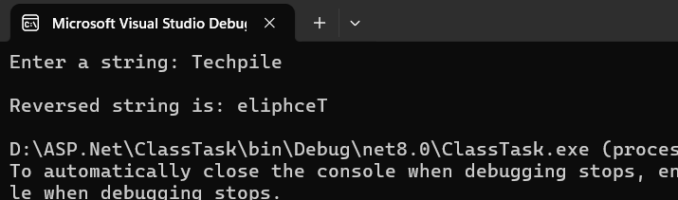

*TASK 2:-*

WAP to input a name and check how many times a char present in your name.

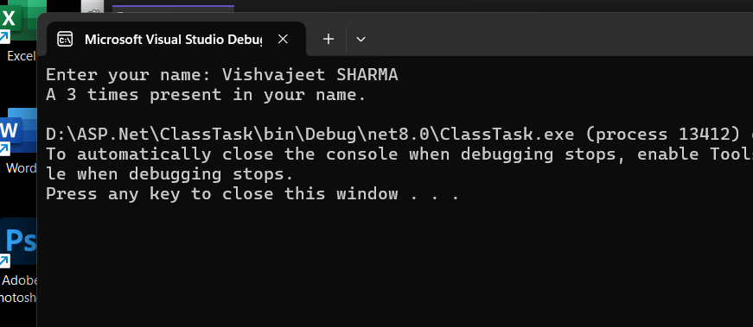

TASK 3:-

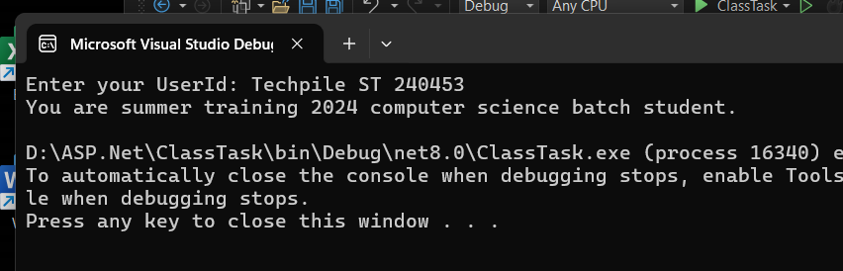WAP to input userId of techpile students and check in which training student in enrolled.

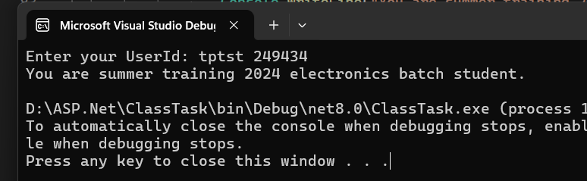

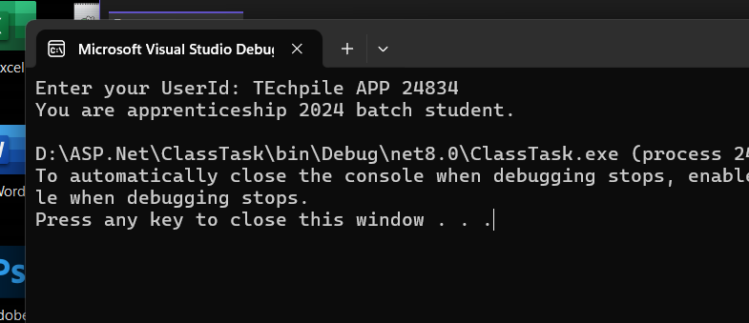

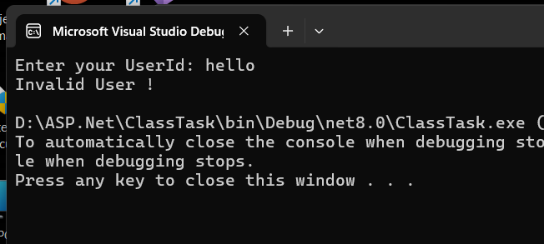

TASK 3:- WAP to input about you and print all in lowercase and uppercase.

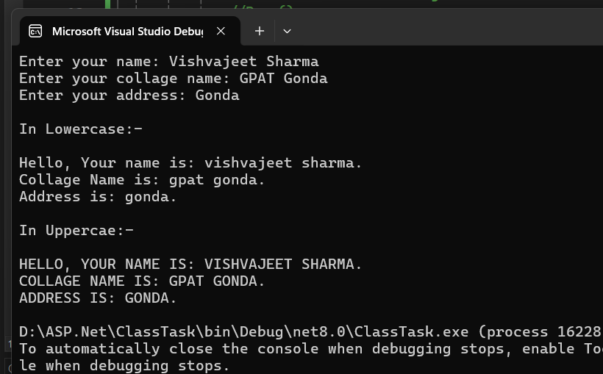

Task 4:- WAP to input emailed of user and print which type of account user have.

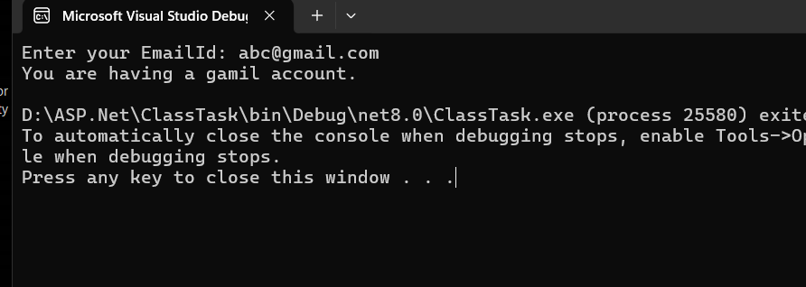

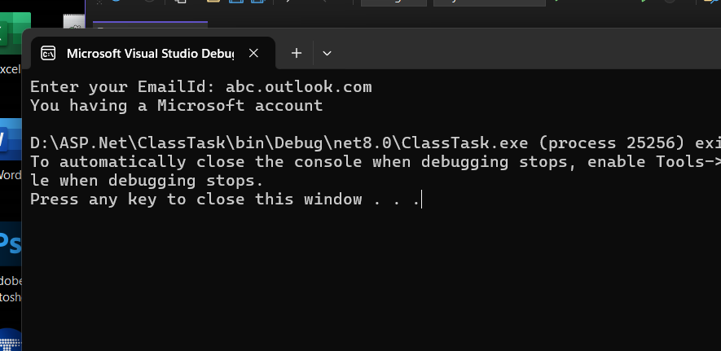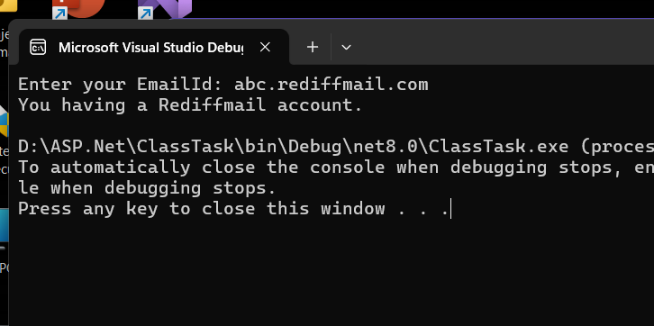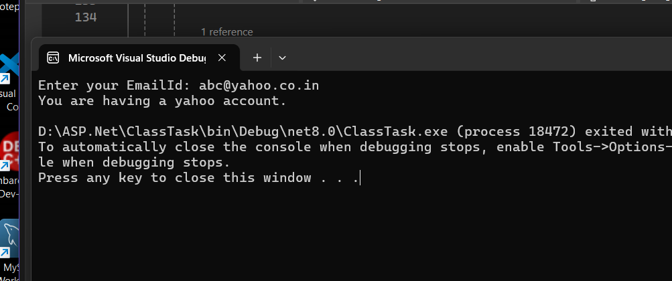

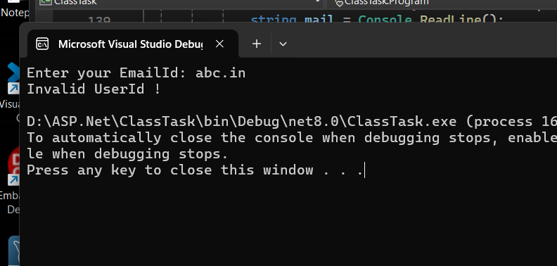

TASK 5:- WAP to input name of your profile picture and check this picture is acceptable or not.

